# CS 470 Module Five Assignment One Guide

## Part One – Creating the Question Table

1. Navigate to the DynamoDB console page. As in the previous modules, navigate to the console through the **Services** drop-down menu and select the service you want – in this case, **DynamoDB**. It is under the **Database** group, or you can type it into the search bar.

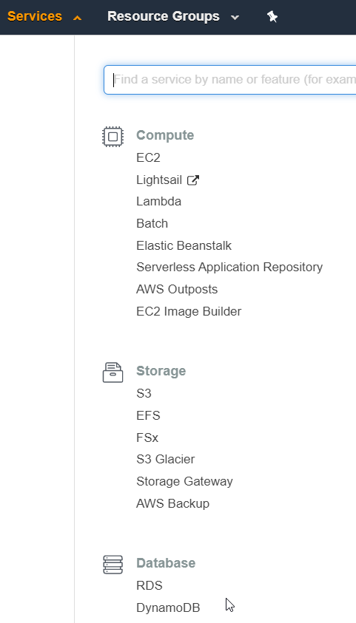

1. Select the **Create Table** button.

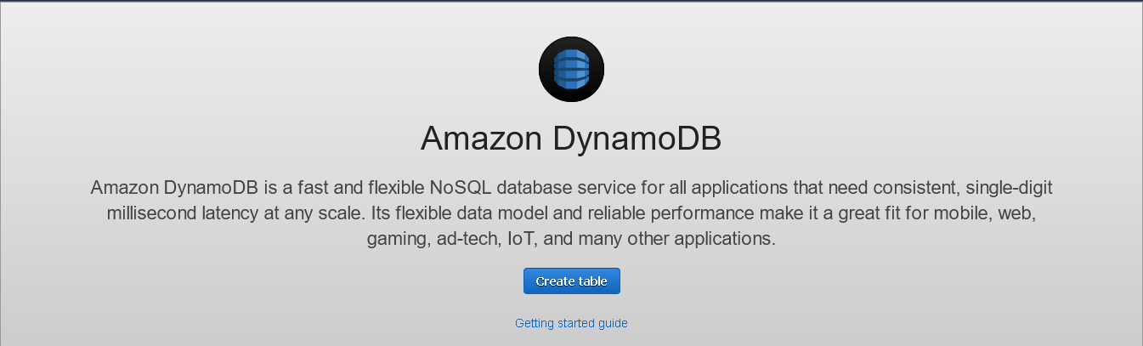

1. Enter a table name of “Question” and Primary Key of “id”, with a type of “string”. Ensure that the “Add sort key” box is unchecked. Click the **Create** button in the lower-right corner.

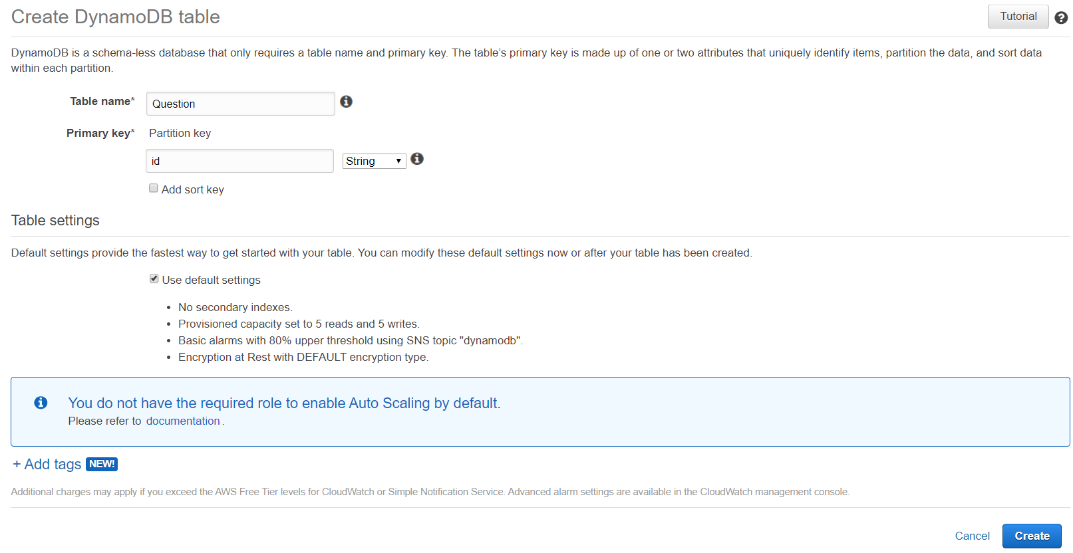

1. AWS will create the table; it may take a minute or two. When it is complete, you will see the table selected and the table details view.

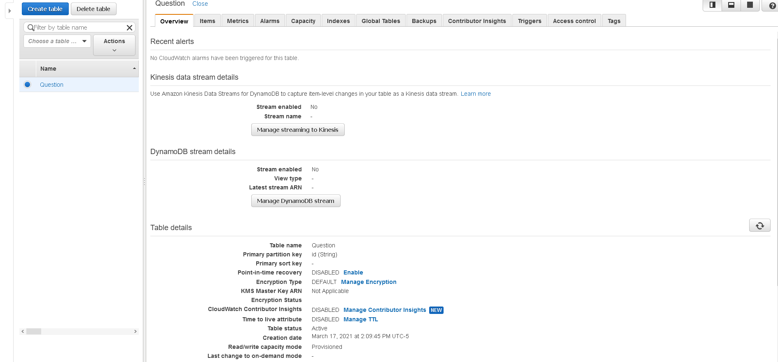

1. Congratulations! You have created your first DynamoDB table.
2. Before moving on to Part Two, select the **Items** tab. The console will have done a table scan and shown you all the records. You have none. It also shows you all your attributes. In this case, you only have one – the partition key “id”. This page will be helpful to you for the rest of this module and the subsequent modules. It allows you to quickly see the items in your database.

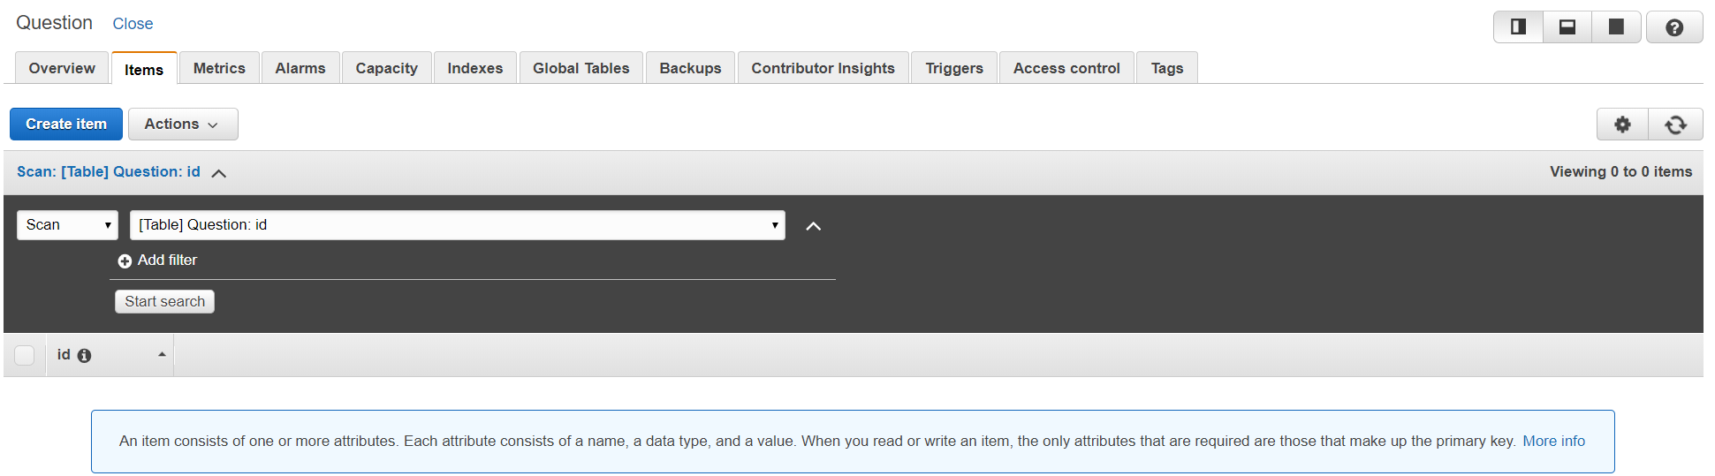

## Part Two – Adding Items and Attributes

1. Since DynamoDB is technically schema-less, it creates a schema based on the items you insert into it. Because of this, you will not add attributes in the traditional way before you insert data. You will add attributes by inserting an item.
2. Picking up from Step 6 in Part One, click the **Create Item** button. The console will show the **Create Item** screen. Here you enter items directly.

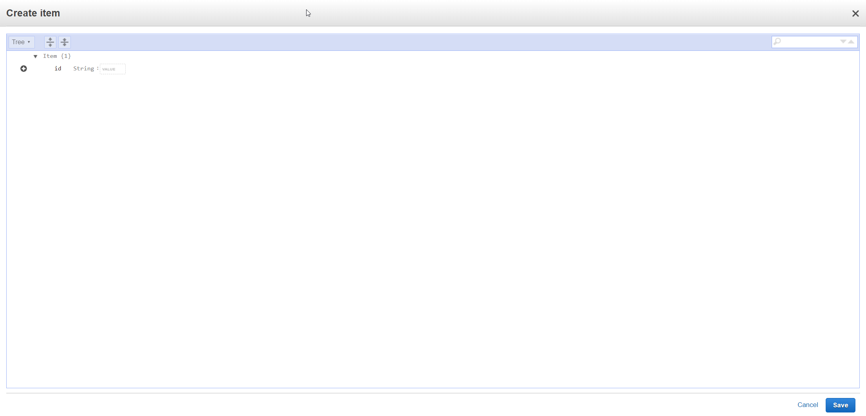

1. Select **Text** from drop-down menu in the upper-left corner. This will allow you to enter items in JSON format instead of attribute-by-attribute in the tree view.

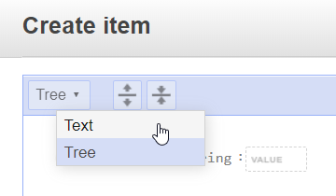

1. Paste the following JSON into the window, overwriting the existing text. A new GUID has been generated as the id to ensure uniqueness.

{

"id": "5eb59b7f80433e00045a7dfb",

"categorySlug": "angular",

"questionSlug": "what-is-angular",

"question": "What is Angular",

"negativeVotes": 0,

"positiveVotes": 0,

"answers": []

}

1. Click the **Save** button in the lower-right corner.

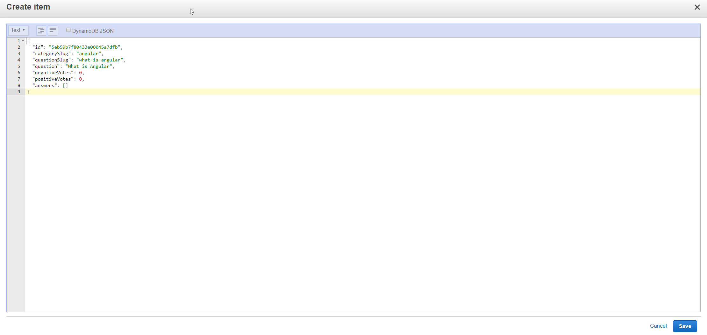

1. You should now be looking at the **Items** tab with a single item shown as such:

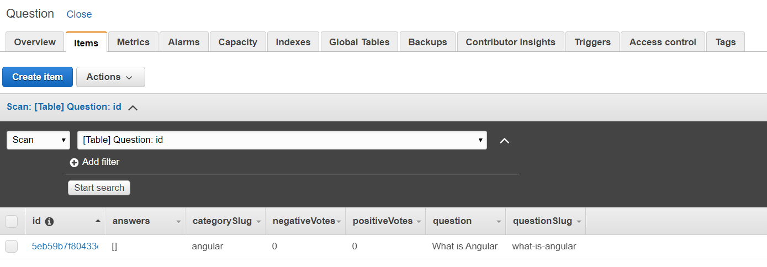

1. As you can see, DynamoDB created the other attributes and populated the item.
2. Select the GUID in the “id” field. This will bring up the **Edit Item** screen.

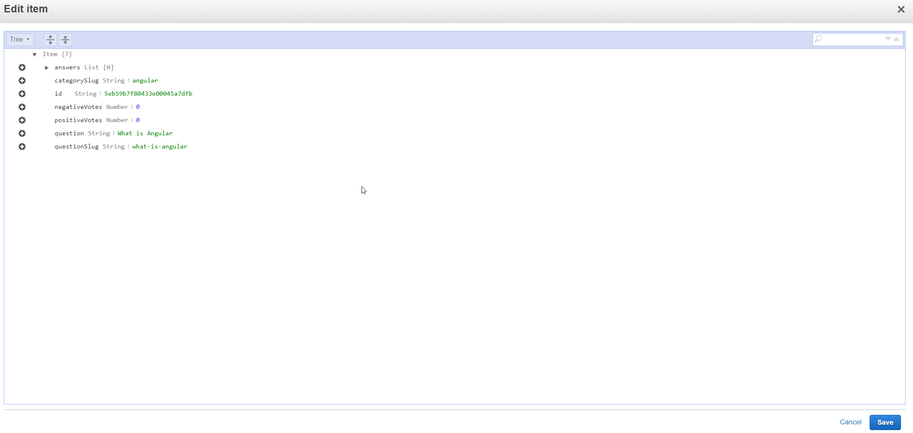

1. From this screen, you can update your record if you need to. Click **Cancel** to exit the editing view.
2. There is one last thing to know about this screen for now. Select the **Actions** drop-down menu next to the **Create Item** button while your item is selected. This allows you to duplicate, edit, or delete an item, or export the table to a CSV file. If you duplicate, you will need to provide a new id value. The “delete” option will ask you to confirm before deleting your item. “Export to .csv” allows you to export your database. “Manage TIL” and “Manage live count” are not relevant to this assignment.

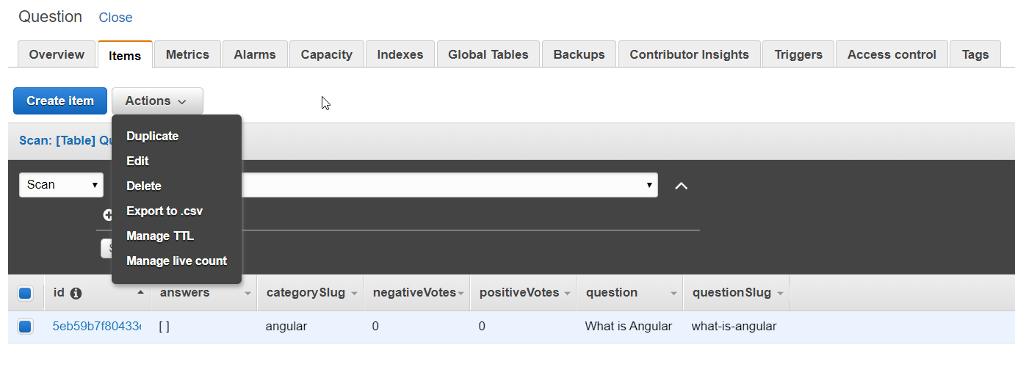

1. Modify the JSON above to create four more Question entries. Make sure each id is unique.
2. Congratulations! You have now created and populated your Question table. You will create the Answer table in Part Three. We could have designed Answer as an array of answer items inside of our Question table, but the Angular application is expecting Answer to act as an independent table.

## Part Three – Creating the Answer Table

1. Using the steps for the Question table, create an Answer table with a partition key of “id” and type of “string”.
2. Select the **Items** tab for the Answer table and create an item using the following JSON data. Make sure the **questionId** matches the id used for an item in your Question table.

{

"answer": "Because it is the backbone of angular",

"negativeVotes": 0,

"positiveVotes": 0,

"id": "5b8629d2af53c20004793ac0",

"questionId": "5eb59b7f80433e00045a7dfb"

}

1. That’s it! You now have your tables and the ability to work with your data through the AWS Console.